Banjo Space Invaders – User Guide

In Banjo Space Invaders you will take control of an accordion spaceship and blast invading banjos that attack from the top of the screen. You goal is to eliminate as many as possible to achieve a high score.

The Menu

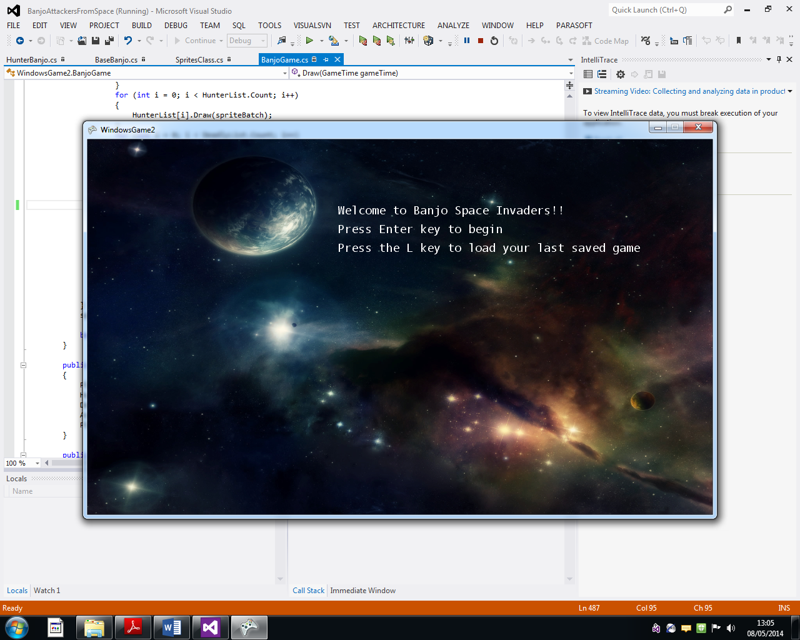

Upon first starting the game you will be presented with the main menu. Pressing the enter key will begin the game with a wave of enemy banjos that will attack immediately. The L key will load the last saved game.

Playing the Game

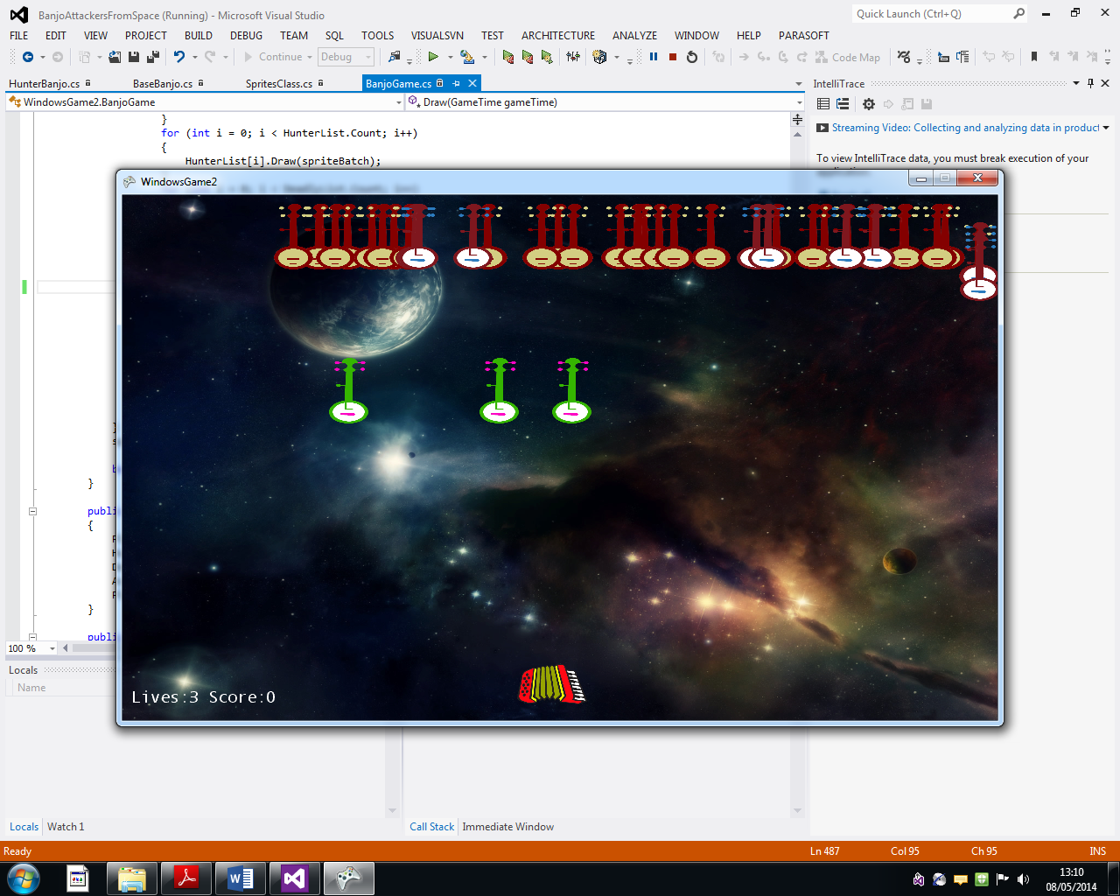

Upon beginning the game you will be assaulted by a first wave of banjos, some more deadly than others. Hit the spacebar to fire a musical note to blast them, you’ll fire as fast as you can hit it. The left and right keys will control your ship.

Know your enemy

**The plain Banjo**



These simple plain banjos will appear in large numbers moving back and forth across the screen till they hit your accordion spaceship. They are weak however and can be destroyed with a single hit.

**The Hunters**



These hunters will attack in groups innocently behaving like their original friends but will home in on your spaceship if ignored for too long. Also like the plain banjo they can be eliminated in a single hit.

**The Deadly Strummer**



Give a hunter some steroids, send him to a gym and he’ll soon come out looking like this. These deadly strummers will not only home in on your accordion ship right from the start, they are also faster and can take multiple hits, BEWARE!!!

Your Accordion Ship



Shooting while moving is the key to quick banjo elimination but take caution! Let any banjos collide with the ship or get past you and you will lose one of your three lives!

Spawning new waves

Hitting the enter key during your game will spawn a fresh wave of banjos, multiple taps of enter will give multiple waves. If you’re feeling daring the go for multiple waves and rack up a high score fast!



Game Over

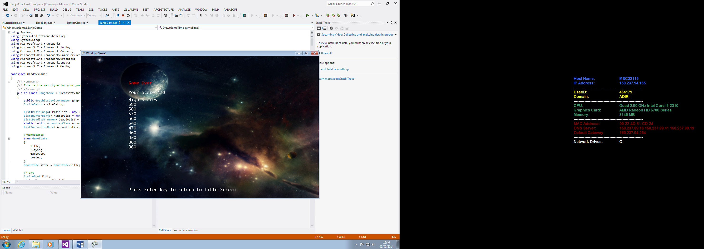

You’ll end up here if you lose all three of your lives. You will then be presented with your score and a list of ten high scores. Go for gold and see if you can reach the top!